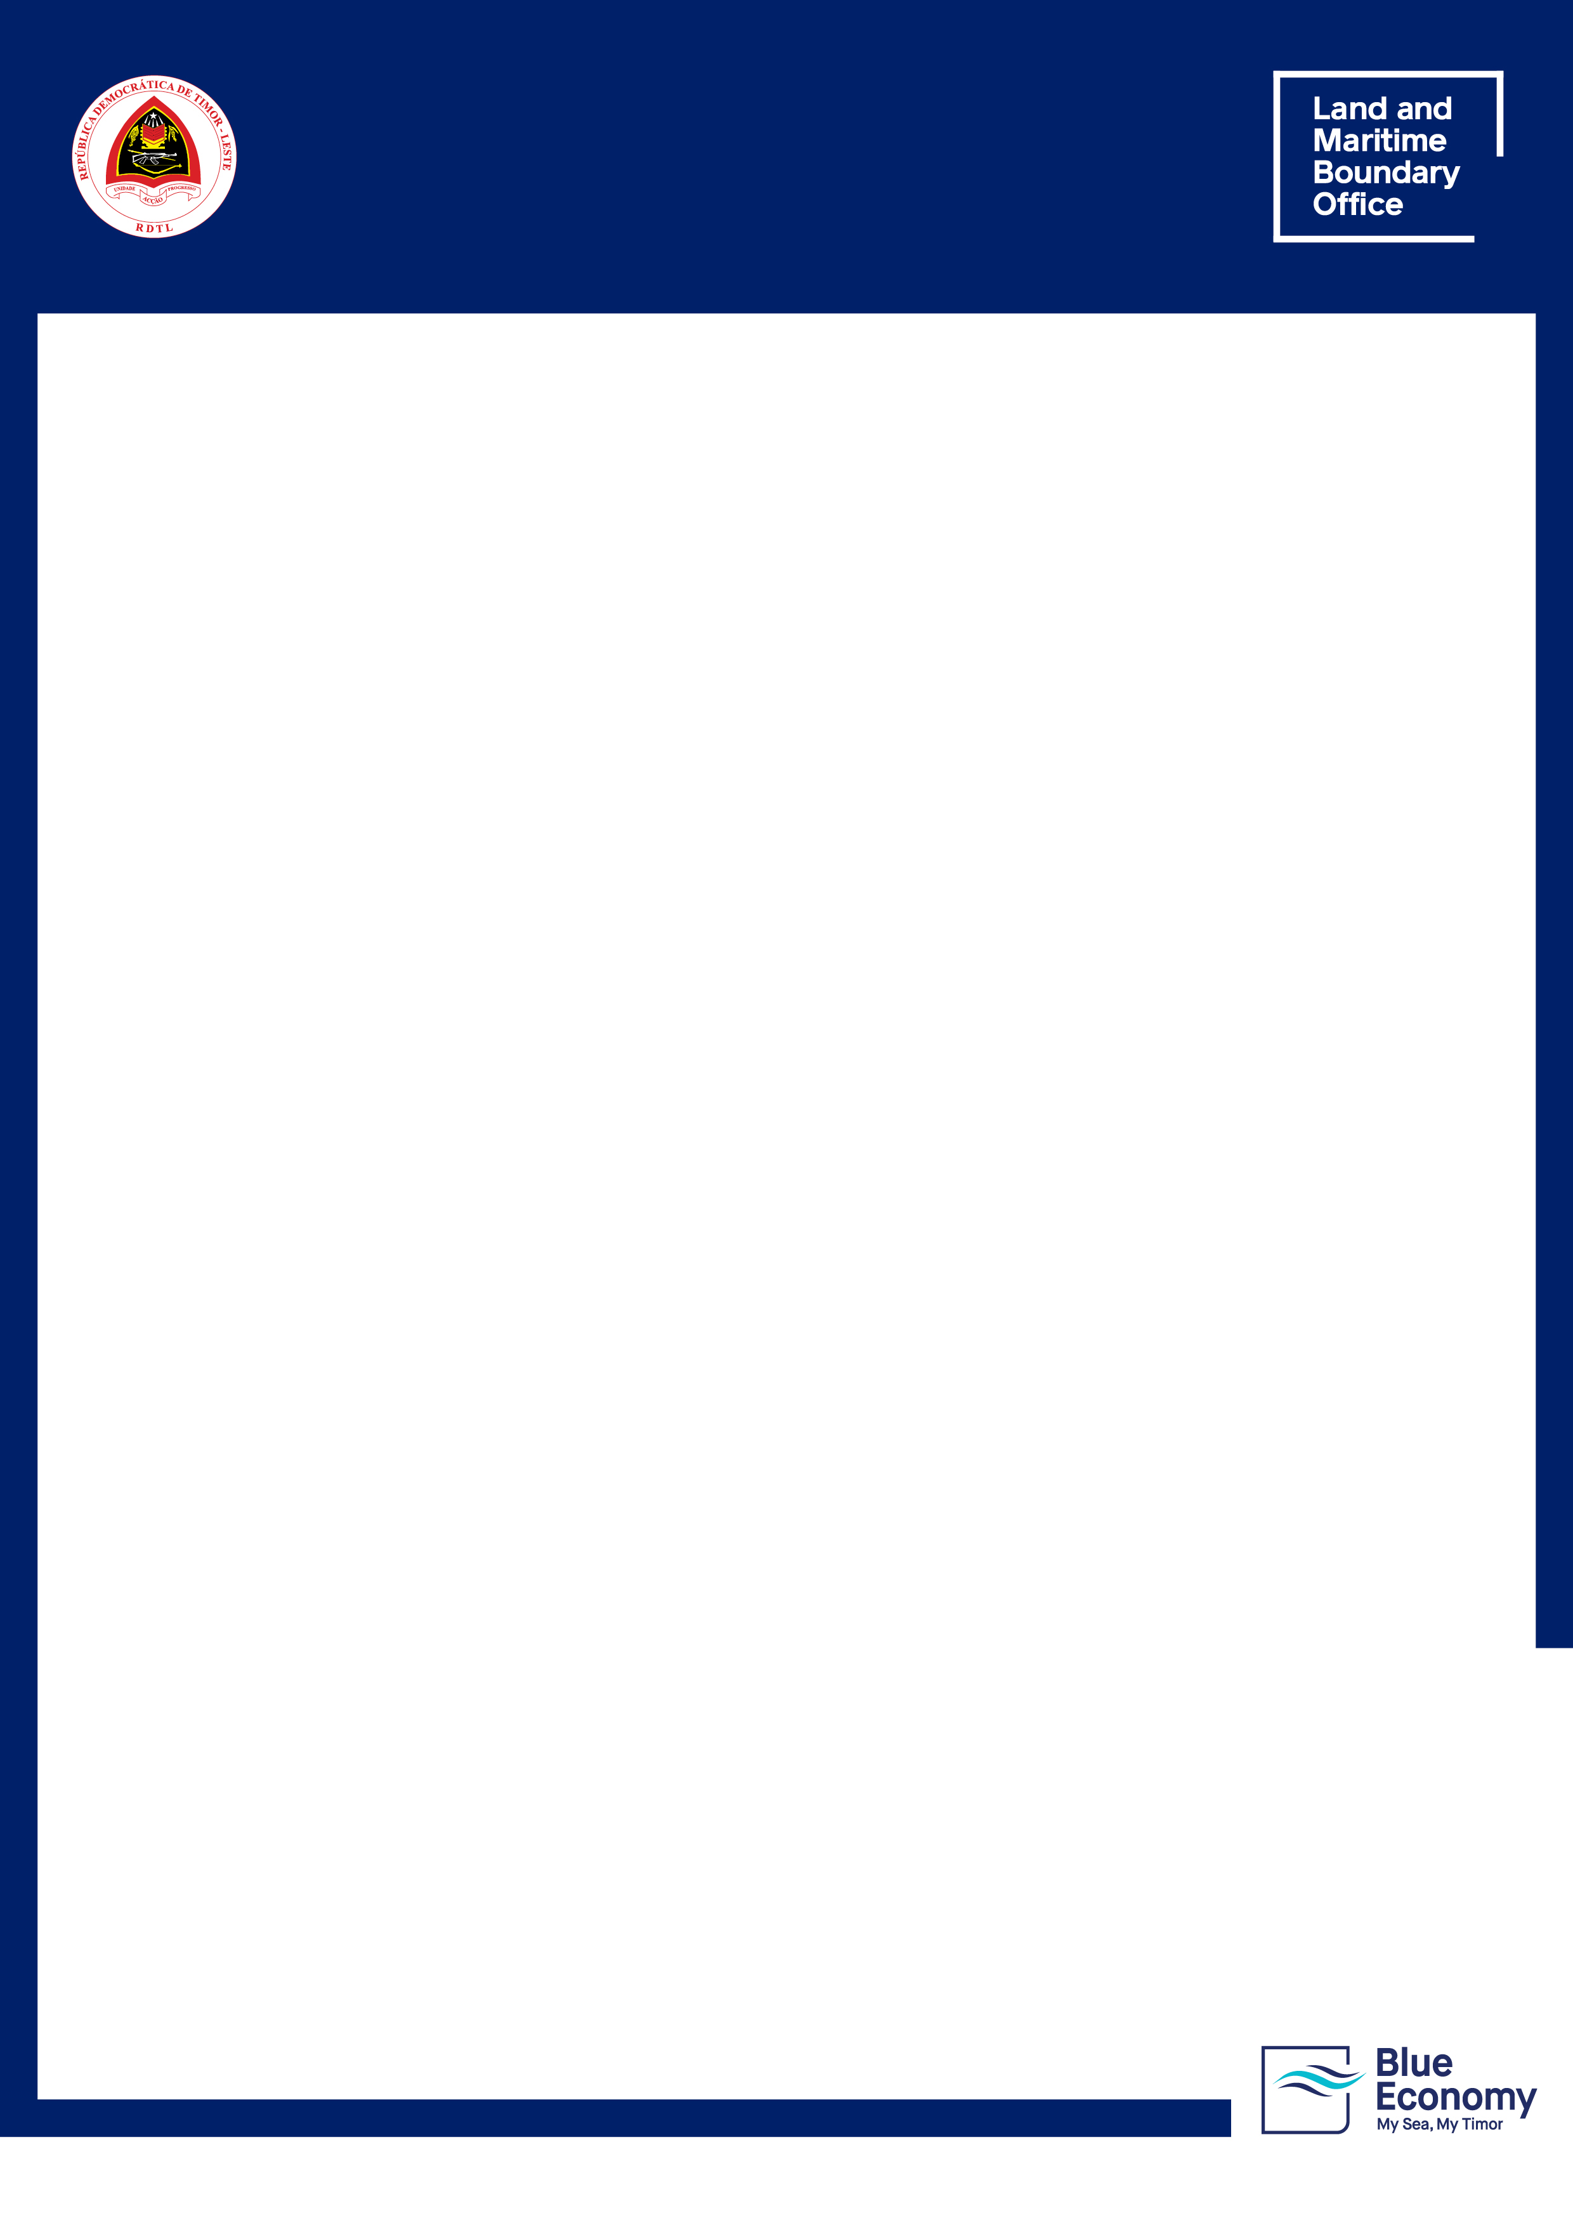

**BLUE ECONOMY: POLICY AND ACTION PLAN   
FOR THE PROMOTION OF A RESILIENT AND SUSTAINABLE ECONOMY OF THE SEA IN TIMOR-LESTE [2025-2035]**

**Consultation Period: 11 – 30 September 2025**

|  |
| --- |
| **Blue Economy Policy and Action Plan for Timor-Leste available HERE or scan below:**    **To submit your feedback:** ✉ [consultapublica@gftm.gov.tl](mailto:consultapublica@gftm.gov.tl) |

**Respondent Details** *(Unidentified forms will not be accepted)*

|  |  |
| --- | --- |
| Full Name |  |
| Title |  |
| Organisation |  |
| Sector (tick one) | ☐ Government ☐ Private ☐ NGO  ☐ Civil society ☐ Academic  ☐ Individual ☐ Other: __________ |
| Email |  |
| Telephone/WhatsApp |  |
| Location (Country/Municipality/City) |  |
| Date (DD/MM/YYYY) |  |

**General Feedback**

**1. General feedback about the Blue Economy: Policy and Action Plan for the Promotion of a Resilient and Sustainable Economy of the Sea in Timor-Leste**

|  |
| --- |
|  |

*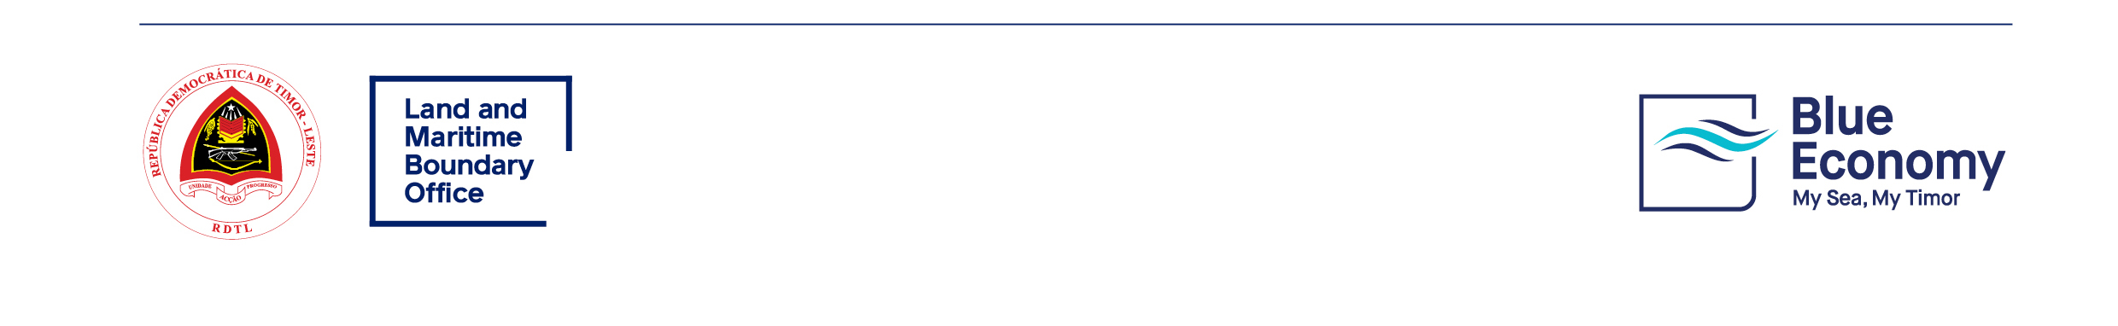** No more than 3 pages (attach additional pages).*

**2. General gaps on the Blue Economy: Policy and Action Plan for the Promotion of a Resilient and Sustainable Economy of the Sea in Timor-Leste**

|  |
| --- |
|  |

*\*\* No more than 3 pages (Attach additional pages).*

**

**Specific Feedback**

|  |  |  |
| --- | --- | --- |
| **Section / Page** | **Comment** | **Suggested change (include source or reference)** |
|  |  |  |
|  |  |  |
|  |  |  |
|  |  |  |
|  |  |  |
|  |  |  |
|  |  |  |

*****\*\* No more than 3 pages*** *(attach additional pages).*

**Additional Clarifications (maximum 3 questions)**

|  |
| --- |
|  |

**